Examples of Aliasing in Real Life

There are many real–life phenomena that result from aliasing, but many do not know that these are actually caused by aliasing. Here we will give two examples.
- When video taping a TV or a PC monitor, sometimes wide black lines appear moving at some constant speed from top to bottom or vice versa across the screen. This results because of the difference in sampling (number of pictures per second) of the video camera and the number of frames the TV or PC monitor display per second.
- When looking at something that rotates at high speed (such as a fan or a car’s wheel), you sometimes see that it is rotating in the opposite direction. This also happens because the human eye works like a video camera where it also takes pictures at a rate close to 24 pictures per second. If the rotating object rotates at a high speed that by the time the eye takes the next picture that object has revolved slightly less than one rotations, this object will appear as if it is rotating in the opposite direction.

Anti–Aliasing Filters

So now we know that when the whenever the bandwidth of the input signal to a sampler is greater than half the sampling frequency (in other words, the sampling frequency is less than twice the bandwidth of the input signal), aliasing will occur. Unfortunately, aliasing does not only destroy the part of the input signal that has frequency greater than half the sampling frequency, but also an equal part of input signal that is below half the sampling frequency. This is illustrated in the figure below.

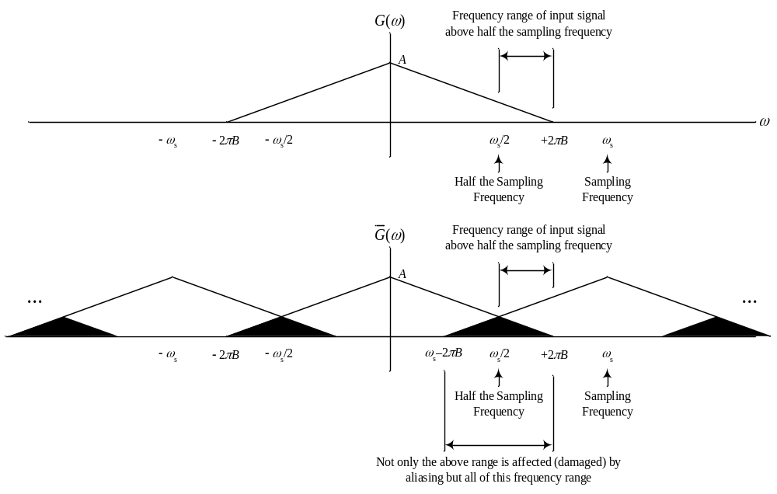

So, it is clear that not only the range of the input signal [ω_{s}/2 , 2πB] gets affected by aliasing, but all the range from [ω_{s}–2πB , 2πB] is affected by aliasing.

To SAVE HALF of the signal in the frequency range [ω_{s}–2πB , 2πB], we can pass the input signal before sampling into a LPF that will cut all the part that is above ω_{s}/2 so that the input signal to the sampling device has a bandwidth of exactly ω_{s}/2. This means that a LPF with bandwidth ω_{s}/2 called ANTI–ALIASING filter must be used. If the input signal to the sampler (which was produced by the anti–aliasing filter) has exactly half the sampling frequency, there will be no aliasing at all (but we will require an ideal LPF with bandwidth ω_{s}/2 to reconstruct the continuous–time signal from the samples). Notice that the original input signal cannot be reconstructed back exactly because we removed part of it to avoid aliasing. Therefore, the block diagram of a practical sampling system is shown below.

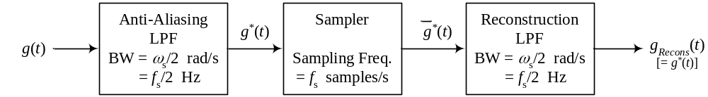

The signals in the above block diagram will be as follows.

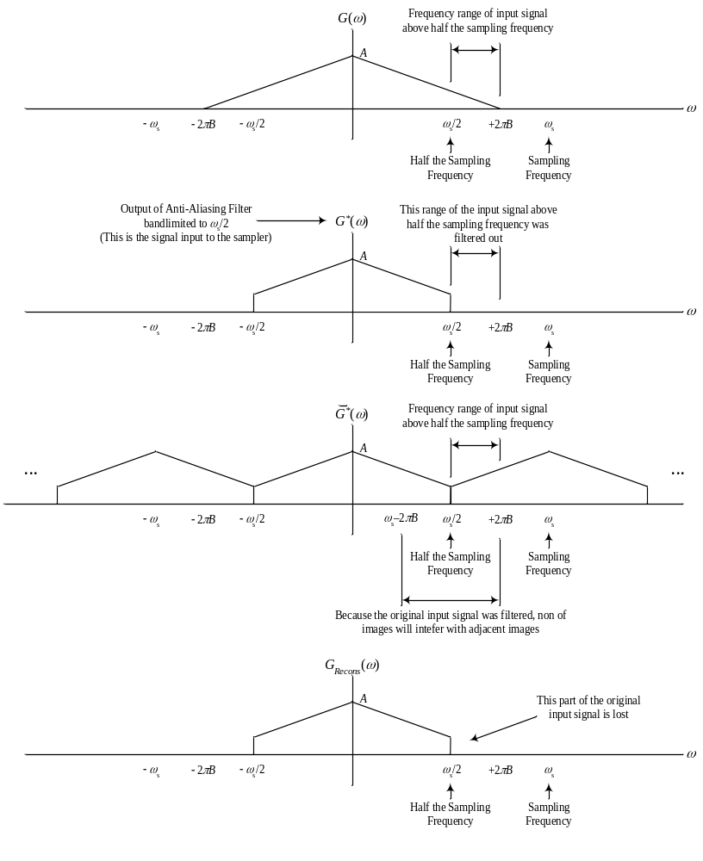So, in conclusion, we can perform sampling with or without using an Antialiasing filter.
Case 1: without using an antialiasing filter: if the sampling frequency is greater than twice the bandwidth of the continuous-time signal, the original continuous-time signal can be reconstructed back from the sampled signal using a suitable reconstruction LPF and no loss of information occurs. If the sampling frequency is less than twice the bandwidth of signal to be sampled, part of the information will be lost (or damaged). This part has the frequency range of ω > ω_{s} – 2πB.

